**Microprocessors**

**Chapter 1: Introduction to Microprocessors**

* 1. **Evolution of Microprocessors**

**4 bit Microprocessors**

**4004**

* Introduced in 1971
* First microprocessor by Intel
* It was a 4-bit microprocessor
* Its clock speed was 740 KHz
* It had 2,300 transistors
* It could execute around 60,000 instructions per seconds
* Used in calculators

**4040**

* Introduced in 1974
* 4-bit microprocessor
* 3,000 transistors were used
* Clock speed was 740 KHz
* Interrupt features were available

**8 Bit Microprocessors**

**8008**

* Introduced in 1972 it was first 8 bit microprocessor
* Its clock speed was 500 KHz
* Could execute 50,000 instruction per second
* Used in: Computer terminals, Calculator, Bottling Machines, industrial Robots

**8080**

* Introduced in 1974
* It was also 8-bit microprocessor
* Its clock speed was 2 MHz
* It has 6,000 transistors
* 10 times faster than 8008
* Could execute 500,000 instructions per second
* Used In: Calculators, Industrial Robots

**8085**

* Introduced in 1976
* It was also 8-bit microprocessor
* Its clock speed was 3 MHz
* Its data bus is 8 bit and address bus is 16 bit
* It has 6,500 transistors
* It could execute 769,230 instructions per second
* It could access 64KB of memory
* It has 246 instructions
* Used In: early PC, On-Board Instrument Data Processors

**16 Bit Microprocessors**

**8086**

* Introduced in 1978
* First 16-bit microprocessor
* Clock speed is 5 to 10 MHz
* Data bus is 16-bit and address bus is 20-bit
* It had 29,000 transistors
* It could execute 2.5 million instructions per second
* Could access 1MB of memory
* It had 22,000 instructions
* Used In: CPU of Microcomputers

**8088**

* Introduced in 1979
* It was also 16-bit microprocessor
* It was creates as cheaper version of Intel’s 8086
* 16-bit processor with an 8-bit data bus
* Could execute 2.5 million instructions per second
* The chip become the most popular in the computer industry when IBM used it for its first PC

**80286**

* Introduced in 1982
* It was 16-bit microprocessor
* Its clock speed was 8 MHz
* Data bus is 16-bit and address bus is 24-bit
* Could address 16 MB of memory
* It has 134,000 transistors
* Could execute 4-million instructions per second

**32 Bit Microprocessors**

**80386**

* Introduced in 1986
* First 32-bit microprocessor
* Data bus is 32 bit and address bus is 32-bit
* It could address 4GB of memory
* It has 275,000 transistors
* Clock speed varied from 16 MHz to 33 MHz depending upon different versions
* Different Versions
* 80386DX
* 80386SX
* 80386SL

**80486**

* Introduced in 1989
* 32-bit microprocessor
* Had 1.2 million transistors
* Clock speed varied from 16 MHz to 100 MHz depending upon the various versions
* It had five different versions
* 80486DX
* 80486SX
* 80486DX2
* 80486SL
* 80486DX4
* 8KB of cache memory was introduced

**Pentium**

* Introduced in 1993
* It was also 32-bit microprocessor
* Clock speed was 66 MHz
* Data bus is 32-bit and address bus is 32-bit
* Could address 4GB of memory
* Could execute 110 million instructions per second
* Cache memory
* 8KB for Instruction
* 8KB for data
* Upgraded Version: Pentium Pro

**Pentium II**

* Introduced in 1997
* 32-bit microprocessor
* Clock speed was 233 to 450 MHz
* MMX technology was supported
* L2 cache and processor were on one circuit
* Upgraded Version: Pentium II Xenon

**Pentium III**

* Introduced in 1999
* It was 32-bit microprocessor
* Clock speed varied from 500 MHz to 1.4 GHz
* It had 9.5 million transistors

**Pentium IV**

* Introduced in 2000
* 32-bit microprocessor
* Clock speed was from 1.3 GHz to 3.8 GHz
* L1 cache was 32 KB and L2 cache was 256 KB
* It had 42 million transistors

**Intel Dual Core**

* Introduced in 2006
* It is 32-bit or 64 bit Microprocessor
* It has 2-cores
* Both cores have their own internal bus and L1 cache but share the external bus and L2 cache
* Support SMT (Simultaneously Multithreading Technology)

**64 Bit Microprocessors**

**Intel Core 2**

* Introduced in 2006
* 64-bit microprocessor
* Clock speed is from 1.2 GHz to 3GHz
* It has 291 million transistors
* L1 cache- 64 KB per core
* L2 cache- 4 MB
* Versions:
* Intel Core 2 Duo
* Intel Core 2 Quad
* Intel Core 2 Extreme

**Intel Core i7**

* Introduced in 2008
* 64-bit microprocessor
* It has 4 physical cores
* Clock speed is from 2.66 GHz to 3.33 GHz
* It has 781 million transistors
* L1 cache- 64 KB per core
* L2 cache- 256 KB
* L3 cache- 4 MB

**Intel Core i5**

* Introduced in 2009
* It is a 64-bit microprocessor
* It has 4 physical cores
* Its clock speed is from 2.40 GHz to 3.60 GHz
* It has 781 million transistors
* L1 cache- 64 KB per core
* L2 cache- 256 KB
* L3 cache- 8 MB

**Intel Core i3**

* Introduced in 2010
* 64-bit microprocessor
* It has 2 physical cores
* Clock speed is from 2.93 GHz to 3.33 GHz
* It has 781 million transistors
* L1 cache- 64 KB per core
* L2 cache- 512 KB
* L3 cache- 4 MB

**Evolution of Microprocessor:**

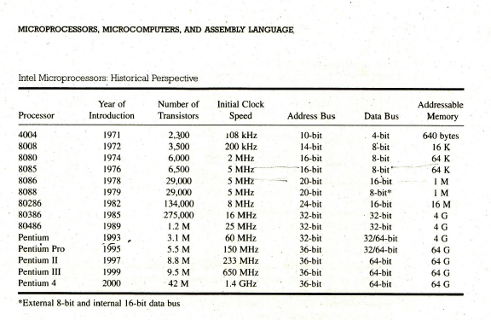

**1.2 Types of Computer Architectures:**

There are two types of computer architectures on the basis of memory locations available for instruction and data namely:

1) Von Neumann Architecture

2) Harvard Architecture

**Von Neumann Architecture**

The Von Neumann Architecture is a design model for a stored-program [digital computer](http://en.wikipedia.org/wiki/Computer) that uses a [central processing unit](http://en.wikipedia.org/wiki/Central_processing_unit) (CPU) and a single separate [storage structure](http://en.wikipedia.org/wiki/Computer_data_storage) ("memory") to hold both instructions and [data](http://en.wikipedia.org/wiki/Data_(computing)). It is named after the [mathematician](http://en.wikipedia.org/wiki/Mathematician) and early [computer scientist](http://en.wikipedia.org/wiki/Computer_scientist) [John von Neumann](http://en.wikipedia.org/wiki/John_von_Neumann). Such computers are theoretically equivalent to a [universal Turing machine](http://en.wikipedia.org/wiki/Universal_Turing_machine) and have a [sequential architecture](http://en.wikipedia.org/wiki/SISD).

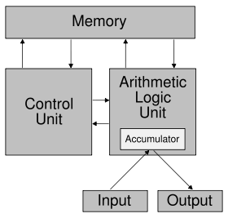

Fig: Von Neumann Computer

**Harvard Architecture**

The Harvard Architecture is a [computer architecture](http://en.wikipedia.org/wiki/Computer_architecture) with physically separate [storage](http://en.wikipedia.org/wiki/Computer_storage) and signal pathways for instructions and data. The term originated from the [Harvard Mark I](http://en.wikipedia.org/wiki/Harvard_Mark_I) relay-based computer, which stored instructions on [punched tape](http://en.wikipedia.org/wiki/Punched_tape) (24 bits wide) and data in electro-mechanical counters. These early machines had limited data storage, entirely contained within the [central processing unit](http://en.wikipedia.org/wiki/Central_processing_unit), and provided no access to the instruction storage as data. Programs needed to be loaded by an operator; the processor could not [boot](http://en.wikipedia.org/wiki/Booting) itself.

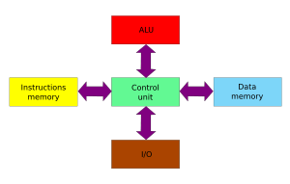

Fig: Harvard Computer

|  |  |
| --- | --- |
| **Von Neumann** | **Harvard Architecture** |
| 1. Simplest architecture | 1. Advanced architecture |
| 1. It has one memory for code and data i.e. efficient use of memory, cheap but data can overwrite instructions | 1. Separate memory for code and data i.e. preventing from overwriting but costlier and inefficient use of memory |
| 1. One address bus for both the code and data memory. | 1. Separate address bus for code and data |
| 1. One data bus for the single memory | 1. Separate data bus for code and data |
| 1. Slower w.r.t Harvard Architecture i..e. data and instruction follow same path to get the processor | 1. Faster w.r.t Von Neumann Architecture |

**Moore’s Law**

In 1965, Intel cofounder Gordon Moore predicted that the numbers of transistors on a chip would double about every two years. This is known as “Moore’s Law”.

**Sample Questions**

1. Describe the Von Neumann’s architecture of a computer system. (5 marks) Fall 2014

2. What are the essential differences between: (8 marks) Spring 2014

i. Von Neumann and Harvard Architecture

ii. Microprocessor and Microcontroller

3. Enlist the greatest breakthrough in microprocessor so that modern processors are available for personal computer. (5 marks) Spring 2015

4. With reference of bus advancement, differentiate between Harvard Architecture and Von Neumann architecture. (5 marks) Spring 2015

5. Define Microprocessor. Compare Intel 8085, 8086, and 80386 Microprocessors on the basis of their features and internal architectures. (7 marks) Fall 2016

**Difference between Calculator & Computer**

Both are devices for which allow the input, storage and manipulation of data. By most definitions the main difference is that a computer can store and execute a set of instructions for performing a series of manipulations on the input data, as opposed to a calculator which usually requires a manual input for each different operation performed.  So the difference is one of versatility rather than computational power.

• Calculator is a handheld device used to perform basic math operations, while a computer is a multipurpose device, which can also perform complex calculations.

• While calculator can carry out one operation at a time, computers, with the help of series of instructions called computer programs can carry out the entire task without assistance.

**1.3 MICROPROCESSORS**

A microprocessor (sometimes abbreviated μP) is a digital electronic component with miniaturized transistors on a single semiconductor integrated circuit (IC) .It is a multipurpose, Programmable clock-driven, register based electronic device that read binary instruction from a storage device called memory, accepts binary data as input and processes data according to those instructions and provides results as outputs. A Microprocessor is a clock driven semiconductor device consisting of electronic circuits manufactured by using either a LSI or VLSI technique.

Three basic characteristics differentiate microprocessors:

• Instruction set: The set of instructions that the microprocessor can execute.

• Bandwidth: The number of bits processed in a single instruction.

• Clock speed: Given in megahertz (MHz), the clock speed determines how many instructions per second the processor can execute.

A typical programmable machine can be represented with three components: MPU, Memory and I/O as shown



These three components work together or interact with each other to perform a given task; thus they comprise a system. The machine (system) represented in above figure can be programmed to turn machine on and off, compute mathematical functions, or keep trace of guidance system. This system may be simple or sophisticated, depending on its applications. The MPU applications are classified primarily in two categories: reprogrammable systems and embedded systems- In reprogrammable systems, such as Microcomputers, the MPU is used for computing and data processing. In embedded systems, the microprocessor is a part of a final product and is not available for reprogramming to end user.

**MICROCOMPUTER**

The term microcomputer is generally synonymous with personal computer, or a computer that depends on a microprocessor. Microcomputers are designed to be used by individuals, whether in the form of PCs, workstations or notebook computers. A microcomputer contains a CPU on a microchip (the microprocessor), a memory system (typically ROM and RAM), a bus system and I/O ports, typically housed in a motherboard.

Microcomputers are small computers. They range from small controllers that work directly with 4-bit words to larger units that work directly with 32-bit words. Some of the more powerful Microcomputers have all or most of the features of earlier minicomputers. Examples of Microcomputers are Intel 8051 controller-a single board computer, IBM PC and Apple Macintosh computer.

**1.3 MICROCONTROLLER**

It is a highly integrated chip that contains all the components comprising a controller. Single-chip Microcomputers are also known as Microcontrollers. They are used primarily to perform dedicated functions. They are used primarily to perform dedicated functions or as slaves in distributed processing.

Generally they include all the essential elements of a computer on a single chip: MPU, R/W memory, ROM and I/O lines and timers. Unlike a general-purpose computer, which also includes all of these components, a microcontroller is designed for a very specific task - to control a particular system. A microcontroller differs from a microprocessor, which is a general-purpose chip that is used to create a multi-function computer or device and requires multiple chips to handle various tasks. A microcontroller is meant to be more self-contained and independent, and functions as a tiny, dedicated computer. The great advantage of microcontrollers, as opposed to using larger microprocessors, is that the parts-count and design costs of the item being controlled can be kept to a minimum. They are typically designed using CMOS (complementary metal oxide semiconductor) technology, an efficient fabrication technique that uses less power and is more immune to power spikes than other techniques. Microcontrollers are sometimes called embedded microcontrollers, which just mean that they are part of an embedded system that is, one part of a larger device or system. Typical examples of the single-chip microcomputers are the Intel 8051, AT89C51, AT89C52 and AVR,PIC. Most of the micro controllers have an 8-bit word size, at least 64 bytes of R/W memory, and 1K byte of ROM, I/O lines varies from 16 to 40.

**APPLICATIONS OF MICROPROCESSOR**

* Microcomputers
* Industrial Control
* Robotics
* Traffic Lights
* Washing Machines
* Microwave Oven
* Security Systems
* On Board Systems

**Difference between Microprocessors and Microcontrollers**

Although both microprocessor and microcontrollers have been designed for real time applications and they share many common features, they have significant differences which are as follows:

|  |  |
| --- | --- |
| **Microprocessors** | **Microcontrollers** |
| 1. Microprocessor is a silicon chip which includes ALU, register circuit and control circuits. | 1. Microcontroller is a silicon chip which includes microprocessor, memory and I/O in a single package. |
| 1. Normally used for general purpose computers as CPU. | 1. Normally microcontrollers are used for specific purposes (embedded system) e.g. traffic light controller, printer, etc. |
| 1. The performance speed, i.e. clock speed of microprocessor is higher ranging frequency from MHz to GHz. | 1. The performance speed of microcontroller is relatively slower than that of microprocessors, with clock speed from 3-33 MHz. |
| 1. Addition of external RAM, ROM and I/O ports makes these systems bulkier and much more expensive. | 1. Has fixed memory and all peripherals are embedded together on a single chip, so are not bulkier and are cheaper than microprocessors. |
| 1. Microprocessors are more versatile than microcontrollers as the designers can decide on the amount of RAM, ROM and I/O ports needed to fit the task at hand. E.gs. Intel 8085, 8086, Motorola 68000, Intel Core i7, etc. | 1. As microcontrollers have already fixed amount of RAM, ROM and I/O ports, so are not versatile as the user cannot change the amount of memory and I/O ports. E.gs. AT89C51, ATmega32, AT89S52, etc. |
| 1. The general block diagram to show microprocessor is as shown | 1. The general block diagram of microcontroller is as shown |

**Microcomputer System**

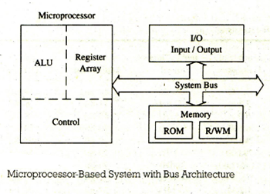

A microcomputer consists of three components:

1) Microprocessor

2) I/O

3) Memory

These components are organized around a common communication path called a bus. Bus is a group of wires to carry bits.

**Bus Architecture**

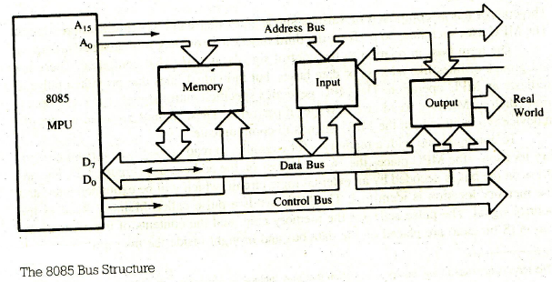

**Address Bus:**

The address bus is unidirectional: bits flow in one direction-from MPU to peripheral devices. The MPU uses the address bus to identify a peripheral device or a memory location. Each peripheral or memory location is identified by a binary number, called an address, and address bus is used to carry this address. Address bus is 16-bit long in 8085 microprocessor.

**Data Bus:**

The data bus lines are bidirectional-data flow from in both directions between memory and peripheral devices. The MPU uses data bus to transfer binary information. In 8085 processor, data bus is 8-bit long.

**Control Bus:**

The control bus is comprised of various single lines that carry synchronization signals. The MPU uses such lines to provide timing signals.

**1.5 Concept of Fetch, Decode and Execution**

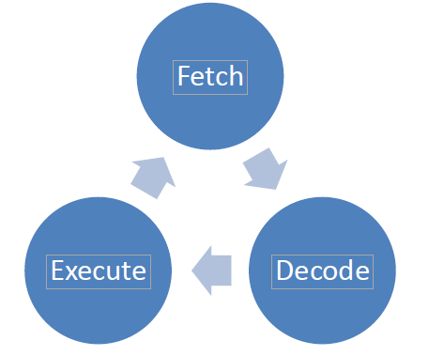

8085 fetches the instructions and data from the memory (RAM), decodes it using the instruction decoder, and finally executes the instruction by activating a corresponding circuit inside an ALU. Once the instruction is executed, the microprocessor goes on fetching the next instruction from the memory. And the process repeats again. This cycle is called Fetch, Decode, and Execute Cycle.